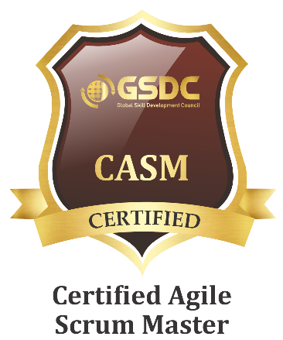
A3/204, Anusaya Enclave
Wanowrie. Pune-411040.
PH.NO. +91-9049989211
EMAIL:wasim3ace@gmail.com

Digital Portfolio: http://wasimakram-mulla.github.io
Total Experience: 6+ Years
WASIMAKRAM H. MULLA

Objective
To work for the most challenging position in an organization to serve as an IT professional, so as to become an essential part of the team and grow with the organization.
Technical Skills
- Angular (2x-7x) - Used angular for creating frameworks, and single page applications with effective response time. Used various Angular features like – Two Way Data-Binding, Templating, Routing, Service calls. Also got an opportunity to work on Angular versions like Angular 5 with Google Cloud.
- ReactJS: Used React for a single project in past experience. Used RxJS help for mapping the response from the REST services.
- VueJS: Learned VueJS, applied Vue in self projects in the portfolio.
- AngularJS: Used angular for creating frameworks, and single page applications with effective response time. Used various Angular features like – Two Way Data-Binding, Templating, MVC, Dependency Injection, Routing, Service calls and Directives.
- HTML 5: Created frameworks with the latest HTML5 features, eg, Audio, Video, Canvas, SVG, etc.
- CSS 3: Used CSS3 media queries and various added features like animation, 3d design, etc. Also have proficient experience in Twitter Bootstrap and responsive design.
- JSON: Created JSON databases and implemented with menus and data integration.
- AJAX: Implemented service calls and fetched data through databases using REST api's. Worked in RESTful services in AngularJs, Angular, ReactJs, and JQuery.
- JQuery: Used jQuery for creating frameworks, and single page applications with effective response time. Used jQuery for extensive animation and effects.
- JavaScript: Used JavaScript for Arrays, Object, Loops and various other features.
Developer Tools: Visual Studio Code, Eclipse IDE, Dreamweaver, Notepad++, etc.

professional summary
- UI Developer with over 6+ years of professional experiences in creating Web Application Development using Web Technologies (Since Sept, 2012).
- Worked on projects where we needed to integrate Google’s Firebase Cloud platform. Integrating Firebase was done using Angular 2’s supporting framework AngularFire2.
- Working in Projects based on Agile Environment since past couple of years.
- Even had an opportunity to work in trending technologies like ReactJs and Vue.
- I have past handful of experience in working for a BFS domain, where UI is one of the crucial part.
- Expertise in consuming RESTful services to send and retrieve data from server side applications.
- Strong experience with Cross Browser Compatibility issues and Optimization for web, including CSS Sprites and best practices.
- Well experienced in using version control systems subversion (SVN), Github (git bash & git gui).
- Experience in Development and Documentation throughout the entire SDLC.
- Experience in designing Rich Internet Application (RIA’s) with AngularJS, JQUERY, and AJAX.
- Up to date Knowledge with the latest industry trends in UI design, development and usability.
- Strong communication, problem-solving, and planning skills, with ability to work independently or in a team environment.

work Experience
- Systems Plus Technologies
Designation: Team Lead.
Responsibilities:
  - My work as an active team member required understanding project requirements, allocation of work to the team members and continuous client interaction.
  - Handling a team of 5-8 UI developers.
  - Participate, oversee, and lead visual design with development efforts on projects.
  - Participate and collaborate with project teams on research and strategic development
  - Lead and work collaboratively with peers, clients, vendors, contractors and other team members
  - Understand technical requirements and work with the user experience team and developers to translate schematics into fully designed experiences.

- Cognizant Technology solutions
Designation: Project Associate
Responsibilities:
  - Develop new user-facing features
  - Collaborate with other team members
  - Optimize application for maximum speed and scalability
- Calsoft Pvt Ltd
Designation: Senior Development Engineer.
Responsibilities:
  - Develop new user-facing features including graphs.
  - Plot historical and current facing graphs up to a request per second.
  - Worked hand in hand with the Python developers to understand and create a better application for the client.
- Aptara New Media Pvt. Ltd.
Designation: Software Developer.
Responsibilities:
- As an E-Learning company, needed to handle various application requests, like Drag and Drop, creating dynamic MCQ’s, etc.
- Got multiple opportunities to work on vast applications and multiple clients simultaneously.
- Got an opportunity to learn all the trending technologies and work on them from the scratch.
I do create projects for self-learning which you can find on my Digital Portfolio below.
Digital Portfolio- http://wasimakram-mulla.github.io

Educational Qualification
Master of Computer Application from University of Pune (Maharashtra) in First Class. I have completed all the subsequent degrees in First Class.

Personal Information
Full Name Mr. Wasimakram Hussain Mulla.
Date of Birth 8th September 1989
Nationality Indian.
Passport Number L7848070 (valid till- 06/03/2024)
Marital Status Married.
I hereby declare that all the above information provided is true and the best of my knowledge and belief.
Place: PUNE Thanking You!
Date: (Wasimakram Hussain Mulla.)

